ITA0515
Computer Vision Lab Programs (05 - 10)

M. SOMESWAR REDDY

192472081
EXP6
Aim
To read a video file in Python and display it in slow motion and fast motion using OpenCV.

Algorithm
- Import the OpenCV library.
- Load the video file.
- Read each frame from the video.
- Display the frame in slow motion.
- Display the frame in fast motion.
- Press Q to stop the video.
- Release the video and close all windows.

Code
import cv2
cap = cv2.VideoCapture("sample.mp4") while True:
ret, frame = cap.read() if not ret:
break cv2.imshow("Video", frame) cv2.waitKey(80)

if cv2.waitKey(1) & 0xFF == ord('q'): break
cap.release() cv2.destroyAllWindows()

Input
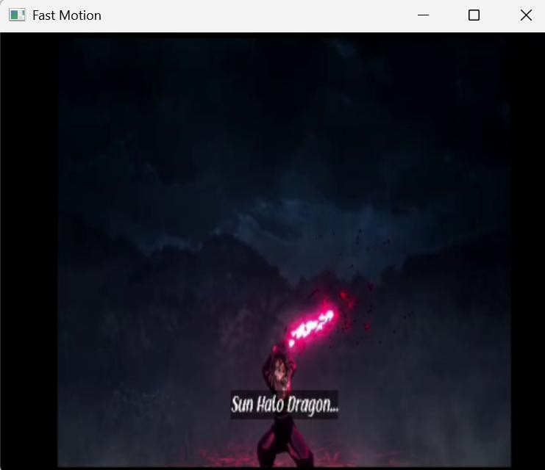

Output
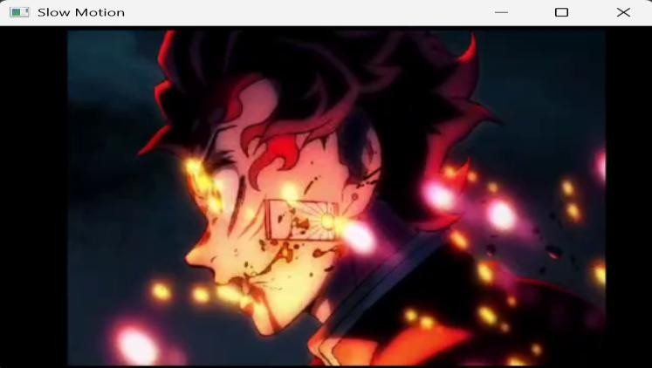

Result
Thus, the program to display a video in slow motion and fast motion was executed successfully.

EXP7

Aim
To capture video from a webcam and display it using OpenCV.

Algorithm
- Import the OpenCV library.
- Open the webcam.
- Capture video frame by frame.
- Display the video.
- Press Q to stop.
- Release the webcam and close all windows.

Code
import cv2

cap = cv2.VideoCapture(0)

while True:
ret, frame = cap.read()

if not ret: break

cv2.imshow("Webcam", frame)

if cv2.waitKey(1) & 0xFF == ord('q'): break

cap.release() cv2.destroyAllWindows()
Input webcam Output
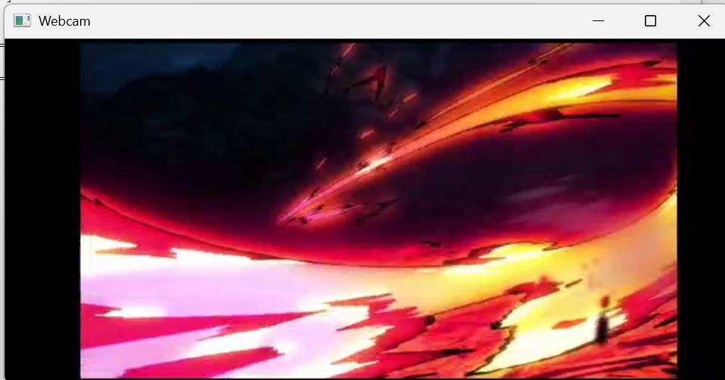

Result
Thus, the program to capture and display webcam video was executed successfully.

EXP8

Aim
To resize an image into bigger and smaller sizes using OpenCV.

Algorithm
- Import the OpenCV library.
- Read the input image.
- Find the image dimensions.
- Resize the image to a bigger size.
- Resize the image to a smaller size.
- Display both resized images.
- Save the output images.

Code
import cv2
image = cv2.imread("image1.jpg") height, width = image.shape[:2]
bigger = cv2.resize(image, (width * 2, height * 2)) smaller = cv2.resize(image, (width // 2, height // 2)) cv2.imshow("Original Image", image) cv2.imshow("Bigger Image", bigger) cv2.imshow("Smaller Image", smaller) cv2.imwrite("bigger_image.jpg", bigger) cv2.imwrite("smaller_image.jpg", smaller) cv2.waitKey(0)
cv2.destroyAllWindows()

Input
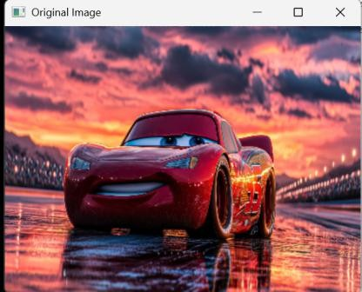

Output
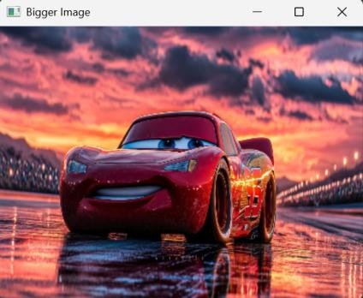

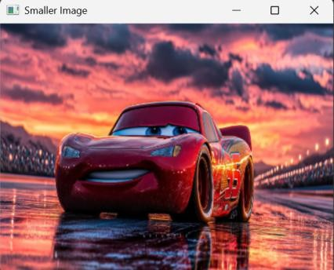

Result
Thus, the program to resize an image into bigger and smaller sizes was executed successfully.

EXP9

Aim
To rotate an image in clockwise and counter-clockwise directions using OpenCV.

Algorithm
- Import the OpenCV library.
- Read the input image.
- Rotate the image clockwise.
- Rotate the image counter-clockwise.
- Display the original and rotated images.
- Save the rotated images.

Code
import cv2
image = cv2.imread("image1.jpg")
clockwise = cv2.rotate(image, cv2.ROTATE_90_CLOCKWISE)
counter_clockwise = cv2.rotate(image, cv2.ROTATE_90_COUNTERCLOCKWISE) display_original = cv2.resize(image, (400, 300))
display_clockwise = cv2.resize(clockwise, (400, 300))
display_counter = cv2.resize(counter_clockwise, (400, 300)) cv2.imshow("Original Image", display_original) cv2.imshow("Clockwise Rotation", display_clockwise) cv2.imshow("Counter Clockwise Rotation", display_counter) cv2.imwrite("clockwise.jpg", clockwise) cv2.imwrite("counter_clockwise.jpg", counter_clockwise) cv2.waitKey(0)
cv2.destroyAllWindows()

Input
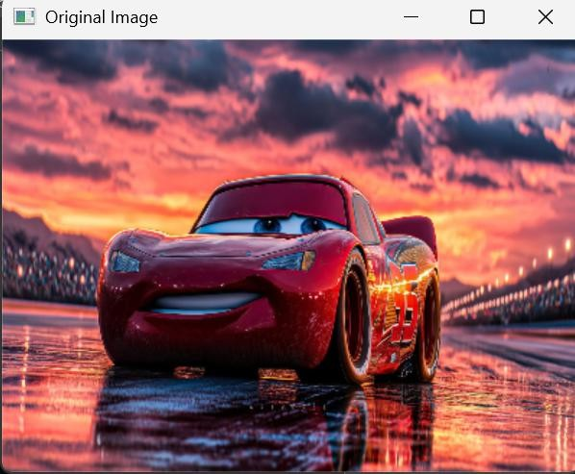
Output
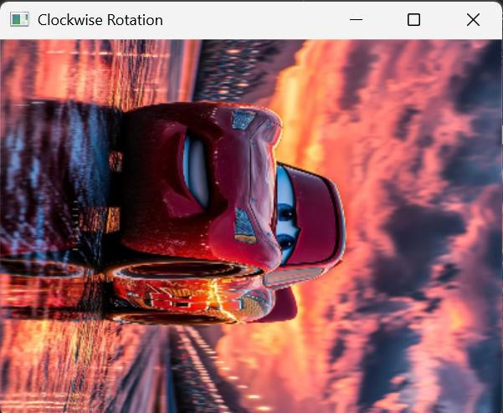
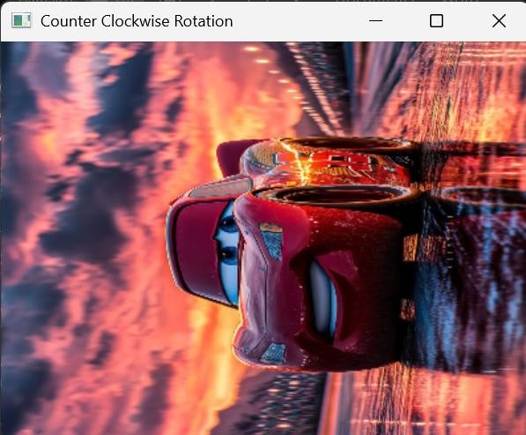

Result
Thus, the program to rotate an image in clockwise and counter-clockwise directions was executed successfully.

EXP10

Aim
To move an image from one position to another on the screen using OpenCV.

Algorithm
- Import the OpenCV library.
- Read the input image.
- Resize the image for display.
- Display the image.
- Move the image window to a new position.
- Wait for a key press and close the window.

Code
import cv2
image = cv2.imread("image1.jpg") image = cv2.resize(image, (400, 300)) cv2.imshow("Original Image", image)
cv2.moveWindow("Original Image", 300, 200) cv2.waitKey(0)
cv2.destroyAllWindows()

Output
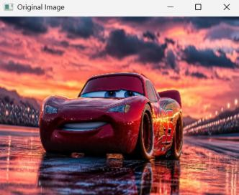

Result
Thus, the program to move an image from one position to another was executed successfully.

